ATM FILES
ATM TERMINAL DATA FILE(ATD): -
-BASE24-atm Terminal Data files contain records for every ATM type terminal in the logical network controlled by the BASE24 network..
-ATD files define the characteristics of the terminal, including the transaction security parameters, sharing parameters, transaction totals, terminal owner, and device-dependent data.
-They are also used to preserve transaction context and are updated every time a transaction is processed for the terminal.
-Data entered on BASE24-atm Terminal Data files (ATD) screens is stored in different files, depending on the type of terminal being defined. For Diebold 10XX/478X and NCR 5XXX Device Handler terminals, data is stored in the BASE24-atm Terminal Data Dynamic File—general data (ATDD1) and the BASE24-atm Terminal Data Static File—general data (ATDS1) files.
-For all other types of ATM terminals, data is stored in the Terminal Data File (TDF).

PRIKEY:- terminal ID
Screen 1:- gives AUTH process name, other than that it shows hardware type, location, state, owner name.
Screen 2:- gives acquirer transaction profile name
Screen 4&5:- shows the hoppers count
Screen 6:- shows terminal activity information.

SCREEN 1

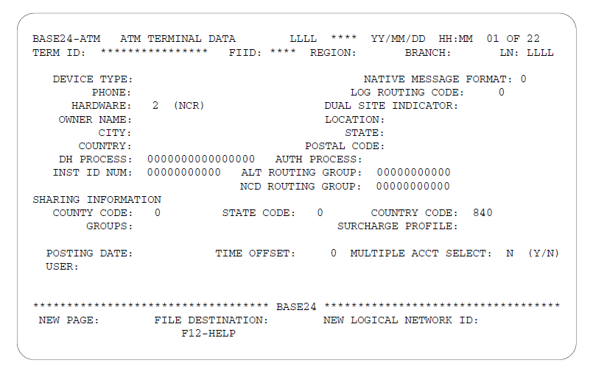

ATD screen 1 contains information about the Device Handler and Authorization processes with which the terminal is associated. It also contains sharing information for the terminal.

i. TERM ID- Identifies the terminal associated with this record. Each entry in the TERM ID field must be unique within the logical network.

ii. FIID- The FIID of the financial institution that owns the terminal. The FIID entered in this field must be defined in the Institution Definition File (IDF). The REGION, BRANCH, and LN fields combine with this field to make one alternate key to the ATD.

iii. BRANCH — The branch ID for the branch in which this terminal is located.

iv. LN — The name of the logical network to which the terminal owner belongs.

v. DEVICE TYPE — A code indicating the type of terminal. Valid values are as follows:

01 = Diebold 910
02 = IBM 3624 Version 8—dual cartridge
04 = Burroughs RT650/750
07 = Fujitsu 910 mode
08 = Fujitsu 911 mode
09 = Diebold 911 Outside
10 = Diebold 911 Lobby
11 = Docutel 5100
14 = IBM 3624 Version 7—single cartridge
15 = IBM 3624 Version 7—dual cartridge
18 = IBM 3624 Version 8—single cartridge
20 = Diebold 912
22 = NCR 5XXX
26 = IBM 4730 single console
27 = IBM 4730 dual console
30 = Diebold 10XX/478X
32 = Olivetti 6000
48 = IBM 3624 Version 8—single cartridge D01
49 = IBM 3624 Version 8—dual cartridge D02
B3 = Triton Mini ATM
B4 = Tidel Anycard ATM
B5 = Fujitsu 7000
B6 = Diebold CashSource Plus
B7 = NCR Cash ATM

vi. NATIVE MESSAGE FORMAT — A code indicating the format of the message from the ATM. The Device Handler process uses this value to determine if the format of the message is standard or non-standard. A standard message format is the native format used by Diebold or NCR. A non-standard message format is Wincor Diebold emulation or the Wincor NCR emulation. Valid values are as
follows:
0 = Standard message format
1 = Non-standard message format

vii. LOG ROUTING CODE — A routing code used by the Device Handler process for all messages logged specifically on behalf of this terminal.

viii. HARDWARE — A code indicating the hardware type. Valid values are as follows:
0 = Unknown
1 = Wincor
2 = NCR
3 = Diebold
4 = Fujitsu
5 = De La Rue
6 = Triton
7 = Olivetti

ix. DUAL SITE INDICATOR — Indicates whether the terminal is operating as a local or remote terminal when part of a dual site support system. Valid values are as follows:
c = Blank. In dual site mode this value is interpreted as Local.
L = Local.
R = Remote.

x. OWNER NAME — The name of the institution that owns the terminal.

xi. LOCATION — The address or location of the terminal. You can configure this information to be printed on cardholder receipts in accordance with Regulation E. Blanks should be left in unused positions to the right.

xii. DH PROCESS — The symbolic name of the Device Handler process for this terminal. This field must match the symbolic name defined by the XPNET process for the Device Handler process associated with this terminal.

Example: P1A^C910

xiii. AUTH PROCESS — The symbolic name of the Authorization process to which transactions from this terminal are to be sent. This field must match the symbolic name defined by the XPNET process.When multiple Authorization processes are used, the XPNET product allows Device Handler processes to send transactions to a service instead of an Authorization process. This is done by specifying the service name in this field rather than an Authorization process name. The service queues transactions and then sends them to the first available Authorization process.

Example: P1A^AUTH1 or ATAUTH

xiv. TIME OFFSET — The time difference, in minutes, between this terminal and the HP NonStop processor location. The value entered is added to or subtracted from the HP NonStop time in order to obtain the terminal local time.

SCREEN 2
ATD screen 2 requires two formats to define parameters required for processing messages.
Screen 2 format 1 defines types of transaction classes for terminals
where the DEVICE TYPE field on ATD screen 1 is set to a value other than 22 or 30.
Screen 2 format 2 defines the acquirer transaction profile, which allows one or more acquirers to share processing code definitions and transactions allowed information.,for terminals where the DEVICE TYPE field on ATD screen 1 is set to a value of 22 or 30.

Format 1
ATD screen 2 format 1 defines the types of transactions allowed for not-on-us cardholders at a particular terminal. The transaction classes listed can vary depending on parameters set up at configuration, although they include all transaction classes allowed at the terminal.

TRANSACTION CLASS
The fields on this screen indicate what transaction classes are allowed for not-onus cardholders at this terminal. Not-on-us cardholders are defined by the BASE24-atm product as those cardholders completing transactions at a terminal owned by a different institution than the institution that issued their card. That is, the terminal-owning institution and the card-issuing institution are not the same.
Transaction Type Description
WITHDRAWAL- A withdrawal from a savings or checking account.

WITHDRAWAL CC- A withdrawal (cash advance) from a credit account.

DEPOSIT- A deposit to a checking or savings account; or a split deposit between two accounts.

INQUIRY- A balance inquiry on any type of account.

TRANSFER- A transfer of funds from one account to another.

ELECTRONIC PAYMENT- A transfer of funds, as a payment, from a checking or savings account to a credit account.

PAYMENT ENCLOSED- An envelope deposited in terminal with a payment enclosed.

MSG TO INSTITUTION- An envelope deposited in terminal with a message to the institution.

LOG ONLY TRANS- Messages that the cardholder can select on the
terminal screen to send to the institution.

CARD REVIEW- A verification of accounts, account balances,
status, and card limits associated with a card.

Valid codes for each of the transactions are as follows:
0 = Not allowed
1 = Allowed within the county
2 = Allowed within the state
3 = Allowed nationally
4 = Allowed internationally

Format 2
ATD screen 2 format 2 defines the acquirer transaction profile for terminals where
the DEVICE TYPE field on ATD screen 1 is set to the value 22 or 30.

ACQUIRER TXN PROFILE- The acquirer transaction profile allows one or more acquirers to share processing code definitions and transactions allowed information. The value in this field is part of the key used to read the Acquirer Processing Code File (APCF) and it overrides the acquirer transaction profile defined at the institution level in the IDF. The value entered in this field must match a transaction profile named in the APCF.

If the Device Handler process does not find the transaction processing code for an acquired transaction in the APCF, the transaction is denied.
If the Device Handler process does find the transaction processing code for an acquired transaction in the APCF, it places the transaction allowed information from the APCF record in the TERM-TRAN-ALLOWED field of the BASE24-atm Standard Internal Message (STM). For not-on-us cardholder transactions, the Authorization process checks the TERM-TRAN-ALLOWED field in the STM to determine whether the
transaction is allowed. For on-us cardholder transactions, the Authorization process does not check this field.

TOKEN RETRIEVAL OPTION — The token data retrieval option determines whether the Device Handler process includes tokens in reversal messages and if so, from where the token data is retrieved. The Device Handler process related to the original transaction obtains the token data from the STM or from extended memory when processing a reversal.
If token data is to be retrieved from the TLF, only tokens configured to be logged to the TLF using the Token File (TKN) are available for the reversal message.
Example: Additional feature is added in ATM for (Biometric access) so to send message to ATM; message format STM and token is send. Since the message format is full and structure cant be changed. So token retrieval is used.

Valid values are as follows:
0 = None. Tokens are not included in the reversal message.
1 = ATD. Token data is retrieved from the ATM Terminal Data
Dynamic File(ATDD2) and appended to the reversal message.
2 = TLF. Token data is retrieved from the Transaction Log File and
appended to the reversal message.
9 = IDF. Token data is retrieved according to the value in the TOKEN
RETRIEVAL OPTION field of the Institution Definition File (IDF).

NOTE ID PROFILE — A code identifying the Note IDs supported at the
terminal. The Note ID profile allows one or more terminals to share Note ID information. The value in this field is the key used to read the Note ID File (NIDF). If the Device Handler process does not find the Note ID information for a Cash Deposit transaction performed on an ATM, the transaction is denied. Note ID information is used to determine the amount of money deposited. Note ID information for a transaction on ATM which supports shared NDC(NCR Direct Connect ) + BNA (Bunch Note Acceptor)

SCREEN 3
ATD screen 3 is displayed in two different formats.Screen 3 format 1 defines special transaction classes for terminals where the DEVICE TYPE field on ATD screen 1 is set to a value other than 22 or 30. Screen 3 format 2 is displayed for terminals where the DEVICE TYPE field is set to the value 22 or 30.

Format 1
ATD screen 3 format 1 identifies the types of special transactions allowed for not on-us cardholders at a particular terminal. The transaction classes listed can vary depending on parameters set up at configuration, although they should include all special transaction classes allowed at the terminal

Screens 4 and 5
ATD screens 4 and 5 contain hopper totals.Screen 4 contains information for hoppers 1, 2, and 3. Screen 5 contains information for hoppers 4, 5, and 6.

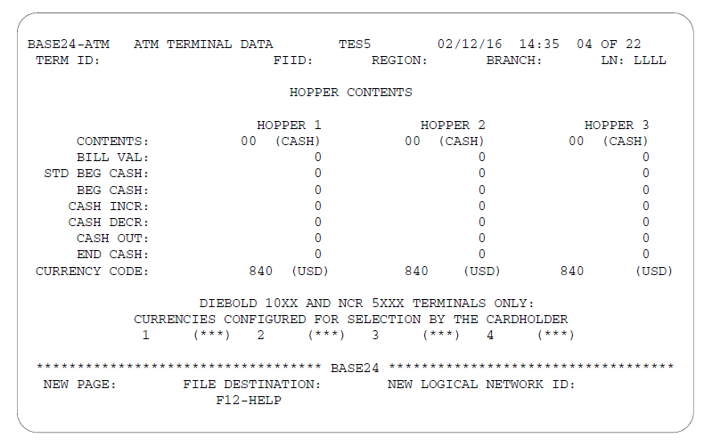

Hopper Content
Contents- Specifies the contents of each hopper. Valid codes are as
follows:
00 = Cash
01 = Coin
02 = Travelers checks
03–10 = Cash value or non value items

*Additional values can be defined by the terminal owner.

BILL VAL — Indicates the denomination of contents of the hopper.

CASH INCR — The amount of money added to the hopper through
administrative midpoint adjustment transactions since the last balancing transaction.

CASH DECR — The amount of money removed from the hopper through
administrative midpoint adjustment transactions since the last balancing transaction.

CASH OUT — The amount of money dispensed from the hopper through
cardholder withdrawals between terminal balancing procedures.

END CASH — The amount of money in this hopper.

CURRENCY CODE — Indicates the currency in the hopper, using ISO
standard codes.

Screens 6

ATD screen 6 contains terminal activity information.
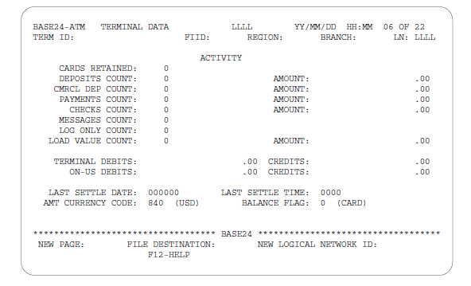

CARDS RETAINED — The number of cards retained at the terminal since the last terminal balancing transaction.

DEPOSITS COUNT — The number of deposit envelopes, excluding
commercial deposits, accepted at the terminal since the last terminal balancing
transaction.

AMOUNT — The unverified amount of the deposits in envelopes, excluding commercial deposits, accepted at the terminal since the last terminal balancing transaction.

PAYMENTS COUNT — The number of payment envelopes accepted at the terminal since the last terminal balancing transaction.

CHECKS COUNT — The number of checks without envelopes cashed and
accepted since the last balancing transaction. This counter can be used to maintain totals for checks received without envelopes if the ATM can distinguish between checks received with envelopes and checks received without envelopes.

MESSAGES COUNT — The number of message-to-institution transaction envelopes accepted at the terminal since the last terminal balancing transaction.

Receipt File (RCPT)
-The Receipt File (RCPT) is used to support the configurable receipt feature for the terminals.
-The BASE24-atm product provides you with configurable receipts, or the ability to customize ATM receipt formats. In addition,
configurable receipts support the display of an informational or marketing message on the cardholder receipt, the use of flexible monetary symbols, multiple language support, and the option to print the account description and account type on the receipt. .
-Configurable receipts include approved and denied financial transaction receipts, statement print headers, and administrative receipts.
-Receipt configuration is supported by receipt group and transaction type.
-Receipt groups are specified for each terminal using the BASE24-atm Terminal Data files (ATD)

Transaction Log File (TLF):-
-All transactions occurring for each BASE24 processing day at terminals
throughout the logical network are logged to the Transaction Log File (TLF).
-The TLF records (one for each cardholder transaction and one for each terminal balancing transaction) are maintained by the BASE24-atm Settlement Initiator process for a set number of days.
-The TLF is written sequentially. You can peruse records in the TLF by reading the file both forward and backward.

You can access TLF records using either one of the following alternate keys:
● Card number
● Terminal ID

The TLF Summary screen that displays the primary account number (PAN)
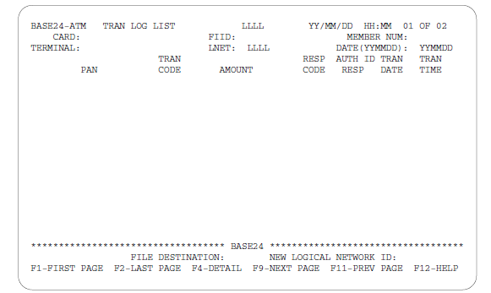

CARD — The card number of the card that initiated the transactions being selected for perusal. Transactions may be selected either by card number or by terminal. Therefore, if a card number is entered in the CARD field, the TERMINAL field must be blank.

FIID — The FIID of the card-issuing or terminal-owning financial institution.

MEMBER NUM — The member number associated with the card number
entered in the CARD field.

LNET — The logical network used to select TLF records for display.

TERMINAL — The terminal ID of the terminal

PAN — The primary account number (PAN) of the cardholder whose TLF
records are displayed.

TRAN CODE — The transaction type associated with this record. The actual numeric transaction code is displayed.

AMOUNT — The requested transaction amount in whole and fractional
currency units.

RESP CODE — The response code assigned by the transaction authorizer.

AUTH ID RESP — The authorization ID response for this transaction.

TRAN DATE/TIME — The date/time when the transaction entered the BASE24 system.

Terminal Receipt File (TRF):-
The Terminal Receipt File (TRF) defines the receipt options for approved and denied transactions that occur at devices with the specified terminal receipt profile defined in the BASE24-atm Terminal Data files (ATD).

Screen 1
The TRF Summary screen 1 is shown below, followed by descriptions of its fields.
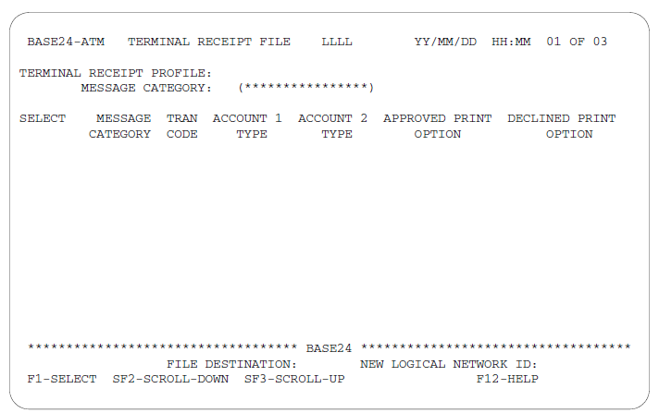

TERMINAL RECEIPT PROFILE — A user-defined name that identifies the terminal receipt profile for the device that initiated the transaction.

APPROVED PRINT OPTION — Identifies the print options for approved transaction receipts.

DECLINED PRINT OPTION — Identifies the print options for declined transaction receipts.

APPROVED/DECLINED PRINT OPTION VALUES
0 = No receipt print, no audit print
1 = Receipt print only, mandatory
2 = Receipt print only, if possible
3 = Audit print only, mandatory
4 = Audit print only, if possible
5 = Receipt and audit, mandatory
6 = Receipt and audit, if possible
7 = Receipt mandatory, audit if possible
8 = Audit mandatory, receipt if possible

Screen 3, Load and Unload
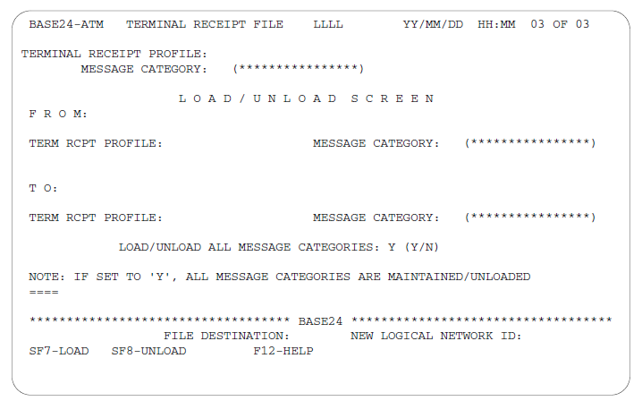

The following two fields identify the terminal receipt profile and the message category from which TRF records are to be loaded (copied) or unloaded (deleted). These fields are valid when used with the F7 and F8 function keys.

TERM RCPT PROFILE — The terminal receipt profile for the device that
initiated the transaction.

MESSAGE CATEGORY — A code that identifies the message category. The message category is the second byte of the ISO message identifier.

The following two fields identify the terminal receipt profile and the message category to which TRF records are to be loaded (copied). These fields are valid when used with the F7 and F8 function keys.

TERM RCPT PROFILE — The terminal receipt profile for the device that
initiated the transaction.

MESSAGE CATEGORY — A code that identifies the message category. The message category is the second byte of the ISO message identifier.

LOAD/UNLOAD ALL MESSAGE CATEGORIES —
A code that is used with the SF7 (LOAD) and SF8 (UNLOAD) function keys to copy or delete records in the TO and FROM Terminal Receipt Profiles. Valid values are Y and N. The following describes the processing of records.
-The SF7 key copies all of the records of the FROM Terminal Receipt Profile to the TO Terminal Receipt Profile when the value in this field is set to Y.
-If the value in this field is set to N, all records of the FROM Terminal Receipt Profile with a specified Message Category are copied to the TO Terminal Receipt Profile.
-The SF8 key deletes all of the records in the FROM Terminal Receipt Profile when the value in the Load/Unload All Message Category field is set to Y.
-If the value in the Load/Unload All Message Category field is set to N, all records of the FROM Terminal Receipt Profile with a specified Message Category are deleted.
-The system generates a message when the unload is successfully completed or an error is encountered.

